Special Educational Needs and
Disabilities (SEND) Information Report

LITTLEBOURNE CE PRIMARY SCHOOL



At Littlebourne, we foster a nurturing, inclusive school community. Following the example of Jesus, we act with compassion to look outwards to serve our neighbour. We empower all to be lifelong, respectful learners who flourish under God's guidance. Through our aspirational curriculum, we grow and thrive together.
Inclusion Team
SEND Governor:
Jess Wood
SENCO:
Mrs Emma Haybourne
Contact No. School Office (01227) 721671 haybournee@littlebourne.kent.sch.uk
Approved by: |  | Full Governing Body Date: December 2025
Last reviewed on: |  | December 2025
Next review due by: |  | December 2026

Contents
- What types of SEND does Littlebourne provide for? ......................................................................... 4
- Which staff will support my child? ..................................................................................................... 5
- What should I do if I think my child has SEND? ................................................................................. 7
- What happens if the school identifies a need? ................................................................................. 8
- How will the school measure my child’s progress? ........................................................................... 9
- How will I be involved in decisions made about my child’s education? .......................................... 10
- How will my child be involved in decisions made about their education? ..................................... 11
- How will the school adapt its teaching for my child? ...................................................................... 13
- How will the school evaluate whether the support in place is helping my child? .......................... 15
- How will the school ensure my child has appropriate resources? ................................................ 15
- How will the school make sure my child is included in activities alongside pupils who don’t have
SEND? ................................................................................................................................................... 16
- How does the school make sure the admissions process is fair for pupils with SEN or a disability?
.............................................................................................................................................................. 17
- How does the school support pupils with disabilities? ................................................................. 18
- How will the school support my child’s mental health and emotional and social development? 18
- What support is in place for looked-after and previously looked-after children with SEN? ........ 19
- What support will be available for my child as they transition between classes or settings or in preparing for adulthood? ..................................................................................................................... 17
- What support is available for me and my family? (Local Offer) .................................................... 22
- What should I do if I have a complaint about my child’s SEND support? ..................................... 24
- Supporting Documents…………………………………………………………………………………………………………….24
- Glossary .......................................................................................................................................... 25

Dear parents and carers,
The aim of this Information Report is to explain how we implement our SEND policy. In other words, we want to show you how SEND support works at Littlebourne CE Primary School.
As educational professionals, we are all working towards the ultimate goal of growing independent young people as they prepare for adulthood. All provision and support we provide is working towards achieving the Kent Children and Young People (CYP) Outcomes Framework:
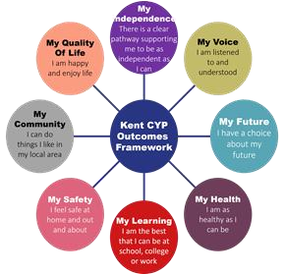
If you want to know more about our arrangements for SEND, read our SEND policy alongside this Information Report.
You can find our SEND policy on our website https://www.littlebourne-kent.co.uk/send-policyinformation-report/
Note: If there are any terms we’ve used in this information report that you’re unsure of, you can look them up in the Glossary at the end of the report.

- What types of SEND does the school provide for?

Our school provides for pupils with the following needs, as outlined in the SEND Code of Practice (DfE/DoH,2015):
  - Cognition and Learning Needs
  - Communication and Interaction Needs
  - Social, Emotional and Mental Health Needs
  - Physical and Sensory Needs

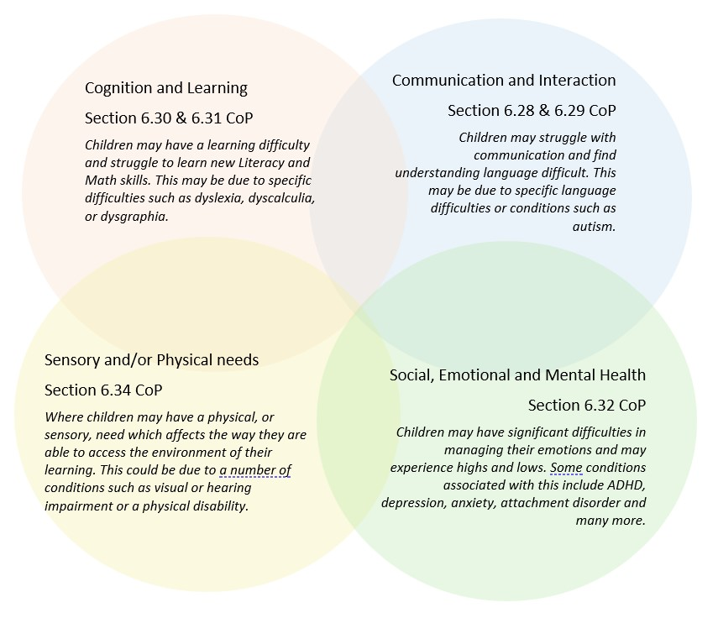

Four Areas of Need
Area of Need | Difficulties associated with this area of need
Communication and Interaction Needs   | Children and young people with needs in this area have difficulty communicating with others.  They may have difficulty understanding what is being said to them, have trouble expressing themselves, or do not understand or use the social rules of communication.  Children and young people, who are on the autism spectrum, often have needs that fall into this category.  Children and young people who have speech and language needs are also identified in this area of need.
Cognition and Learning Needs  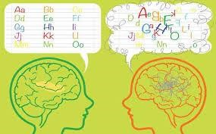  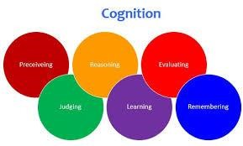 | Children and young people with learning difficulties usually learn at a slower pace than their peers. These are typically identified by categorisation as either general or specific learning difficulties, which may also include difficulties associated with delayed processing and/or working memory.  A wide range of needs are grouped in this area, including:  - Specific learning difficulties, which impact 1 or more specific aspects of learning, such as: dyslexia, dyscalculia and dyspraxia  - Moderate learning difficulties  - Severe learning difficulties  - Profound and multiple learning difficulties, which is where children and young people  are likely to have severe  and complex learning difficulties, as well as a physical disability or sensory impairment
Social, Emotional and Mental Health Needs   | These needs may reflect a wide range of underlying difficulties or disorders.  Children and young people may have:  - Mental health difficulties such as anxiety, depression or an eating disorder  - Attention Deficit Disorder(ADD), Attention  Deficit Hyperactivity Disorder  (ADHD) or attachment disorder  - Suffered adverse childhood experiences (ACEs).  These needs can manifest in many different ways, for example externally presented as challenging or dysregulated behaviour, or internally presented by the child or young person becoming withdrawn or isolated.
Sensory and/or Physical Needs  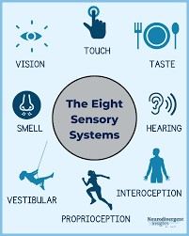 | Children and young people with these needs have a disability that hinders them from accessing the educational facilities generally provided.  Children and young people may have:  - A sensory impairment such as vision impairment, hearing impairment or multisensory impairment  - A physical impairment  These children and young people may need ongoing additional support and additional equipment in order to access the same opportunities available to their peers.


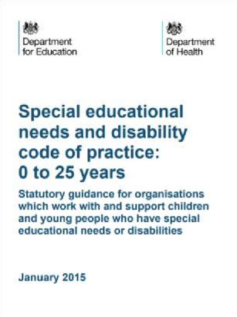
Often you will find that children’s needs overlap and are rarely confined to one area of need, which is why it is important to gain a holistic overview of your child.
More information about the Areas of Need can be found in the Special Educational Needs and Disability Code of Practice: 0 to 25 years (DfE/DoH, 2015):
SEND_Code_of_Practice_January_2015.pdf (publishing.service.gov.uk)

- Which staff will support my child, and what are their key responsibilities?
Our Special Educational Needs Co-ordinator, or SENCO
At Littlebourne CE Primary School all staff are considered responsible for supporting the needs of pupils with SEND. Our staff are committed to regular, high-quality training to ensure that they have the knowledge and skills to better meet a wide range of pupil needs.
Mrs Haybourne is our School SENCO

The SENCO at Littlebourne CE Primary School is Mrs Emma Haybourne, who is an experienced qualified teacher. The SENCO at Littlebourne CE Primary School is Mrs Emma Haybourne, who is an experienced qualified teacher. In line with national requirements, Mrs Haybourne is working towards achieving the National Award for SEN Co-ordination.
Mrs Haybourne is an experienced qualified teacher who has a deep commitment to inclusive education and adaptive teaching practices. Mrs Haybourne is passionate about ensuring every child feels seen, supported, and empowered to thrive, regardless of their starting point. In order to support this she has completed many additional courses including Primary Initial Teacher Training Mentoring, Understanding and Supporting Pupils with Pathological Demand Avoidance and Understanding and Supporting Autism in Girls.

Mrs Haybourne works part-time as SENCO on Monday, Tuesday and Wednesday and is available via the School Office on (01227) 721 671 or haybournee@littlebourne.kent.sch.uk
Class/subject teachers
All of our teachers receive in-house SEN training, and are supported by the SENCO to meet the needs of pupils who have SEN.
Our whole school staff team have been involved in training delivered by The Autism Education Trust
Staff.
All teaching staff are trained to use The Mainstream Core Standards.

Teaching assistants (TAs)
We have a team of 6 TAs, including 1 higher-level teaching assistants (HLTAs), who are trained to deliver SEN provision.
We have a number of teaching assistants who are trained to deliver interventions such as Dyscalculia Solutions, Alpha To Omega, Language Link, Lego Therapy Intervention, Little Wandle and many more. One of our TAs is training to become a Level 5 TISUK Trauma informed Practitioner, in order to deliver bespoke SEMH interventions for identified children.
In the last academic year, TAs have been trained in Lego Therapy Intervention, Little Wandle, Autism, Clever Hands, Alphabet Arc work.

External agencies
Sometimes we need extra help to offer our pupils the support that they need. Whenever necessary we will work with external support services to meet the needs of our pupils with SEND and to support their families.
These may include:
Child and adolescent mental health services (CAMHS)  Education welfare officers  Educational Psychologists  GPs or paediatricians  NELFT practitioners  Occupational therapists  Physiotherapists  Safeguarding services including Early Help workers |  | School Liaison Officer  School nurses  SEND Inclusion Advisor  Specialist Teacher Service  Speech and language therapists  Therapeutic practitioners  Voluntary sector organisations  VSK – Virtual Schools Kent





- What should I do if I think my child has SEND?
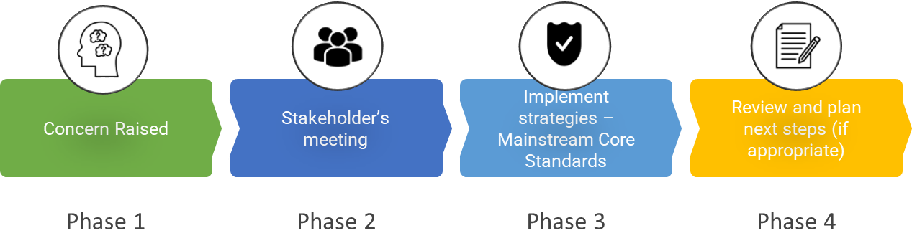

Phase 1  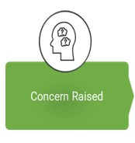 | If you think your child might have SEND, raise your concern with the school so that the school staff and SENCO are aware.  The easiest way to do this is to make an appointment to meet with your child’s class teacher in the first instance. This can be done via the school office: office@littlebourne.kent.sch.uk
Phase 2  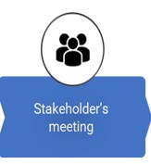 | We will meet with you to discuss your concerns and try to get a better understanding of what your child’s strengths and difficulties are. Together we will decide what outcomes to seek for your child and agree on next steps. We will make a note of what’s been discussed and add this to your child’s record.
Phase 3  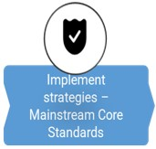 | We will implement the agreed strategies and monitor these over an agreed period of time. These are likely to be universal strategies set out in the mainstream core standards. A copy of this can be found here:  https://www.kelsi.org.uk/__data/assets/pdf_file/0005/117257/Specialeducational-needs-mainstream-core-standards-guide-for-parents.pdf .  This will initiate the ‘Graduated Approach’ where support will be continually reviewed. See next page for more details.
Phase 4 | If we decide that your child needs SEND support, we will formally notify you and your child will be added to the school’s SEND register or SEN with
Together, we grow, thrive, achieve

9

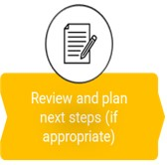 | Support. They will receive additional support and this will be reviewed using the assess, plan, do, review model.
- What happens if the school identifies a need?
The same process is followed if a concern is raised by the school.

All our class teachers are responsible for the monitoring of all pupils who have been identified as having SEND. They also review those who are not making the expected level of progress in their schoolwork or socially. This might include reading, writing, number work, social communication, fine motor skills, gross motor skills etc.
If the teacher notices that a pupil is having difficulties, they will further explore this to find out if the pupil has any gaps in their learning. If they can find a gap, the school will provide appropriate support. Pupils who don’t have SEND usually make progress quickly once the gap in their learning has been filled.
If the pupil is still finding it difficult to make the expected progress, the teacher will talk to the SENCO, and will contact you to discuss the possibility that your child has SEND, and the school will follow the graduated approach (see previous page).

- How will the school measure my child’s progress?
We follow the ‘graduated approach’ to meeting your child’s SEND needs.
The graduated approach is a 4-part cycle made up of assess, plan, do, review.
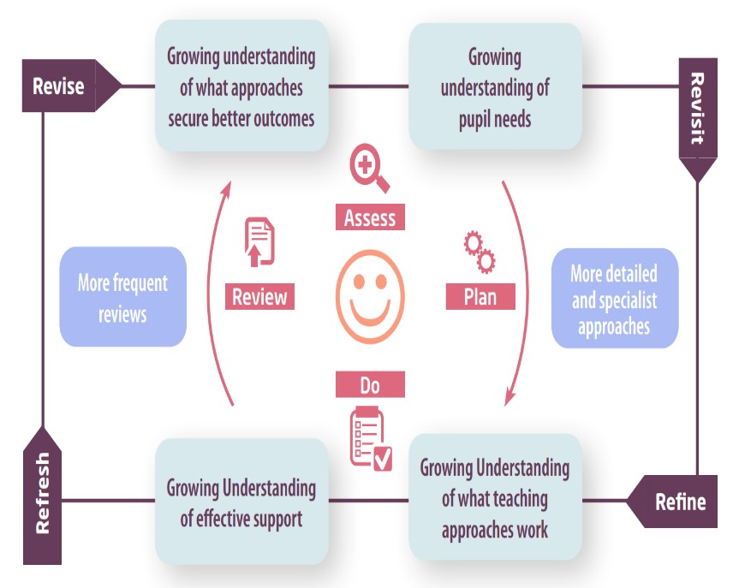
Assess  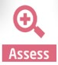 | If your child is not making the expected level of progress, we will make an assessment to find out what strengths and difficulties your child has. We will ask for you and your child’s input, as well as getting help from external professionals where necessary.
Plan  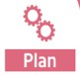 | In discussion with you and your child, we will decide what outcomes we are hoping to achieve. We will make a plan of the support we will offer your child to help them meet those outcomes. We will make a record of this and share it with you and all relevant school staff.
Do   | We will put our plan into practice.  The class teacher and TA, with the support of the SENCO, will be responsible for working with your child on a daily basis, and making sure the support we put in place is having the impact we intended.
Review   | We will assess how well the support we put in place helped your child to meet the outcomes we set. We will use our improved understanding of your child’s needs to improve the support we offer; this may mean the Plan, Assess, Do, Review cycle continues.

- How will I be involved in decisions made about my child’s education?

We will provide annual reports on your child's progress.
If your child has more complex needs, a member of staff who knows your child well will meet you 3 times a year in order to:
Set clear outcomes for your child’s progress
Review progress towards those outcomes
Discuss the support we will put in place to help your child make that progress
Identify what we will do, what we will ask you to do, and what we will ask your child to do

The SENCO may also attend these meetings to provide extra support.
We know that you’re the expert when it comes to your child’s needs and aspirations. We want to make sure you have a full understanding of how we’re trying to meet your child’s needs, so that you can provide insight into what you think would work best for your child.
We also want to hear from you as much as possible so that we can build a better picture of how the SEND support we are providing is impacting your child outside of school.
If your child’s needs or aspirations change at any time, please let us know right away so we can keep our provision as relevant as possible.
If you have concerns that arise between these meetings, please contact the SENCO haybournee@littlebourne.kent.sch.uk or your child’s class teacher via the school office office@littlebourne.kent.sch.uk

- How will my child be involved in decisions made about their education?

The level of involvement will depend on your child’s age, stage and individual needs. We recognise that no two children are the same, so we will decide on a case-by-case basis, with your input.
We may seek your child’s views by asking them to:
Attend meetings to discuss their progress and outcomes
Prepare a presentation, written statement, video, drawing, etc.
Discuss their views with a member of staff who can act as a representative during the meeting
❖ Complete a survey


- How will the school adapt its teaching for my child?

Your child’s teacher is responsible and accountable for the progress and development of all the pupils in their class, including those with additional needs and requirements and those with SEND.
High-quality teaching is our first step in responding to your child’s needs. We will make sure that your child has access to a broad and balanced curriculum in every year they are at our school.
We will adapt our approaches to how we teach to suit the way your child works best. There is no 'one size fits all’ approach to adapting the curriculum. We work on a case-by case basis to make sure the adaptations we make are meaningful to your child and are guided by the Mainstream Core Standards in the first instance.
These adaptations may include:


  - Adapting our approaches, for example, giving longer processing times, pre-teaching of key vocabulary, reading instructions aloud, etc.

  - Adapting our resources and staffing


  - Using recommended aids, such as laptops, coloured overlays, visual timetables, larger font, etc.

  - Teaching assistants or support staff will support pupils appropriately depending on their presentation of need

  - Scaffolding lesson materials
We may also provide the following interventions:

  - Alpha To Omega
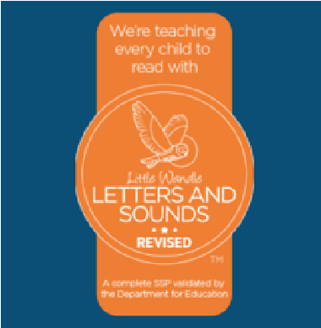
  - Toe by Toe
  - Targeted Alphabet Arc Work
  - Language Link
  - Dyscalculia Solutions
  - Power of 1
  - Power of 2

  - White Rose support
  - Little Wandle Catch up
  - Little Wandle SEND Programme
  - Touch Typing
  - Fizzy Programmes
  - Clever Hands Programme

  - Sensory Circuits
  - Lego Therapy Intervention
  - Targeted Zones of Regulation support

  - Incredible 5 Point Scale support
  - TISUK targeted interventions
These interventions are part of our contribution to Kent County Council’s local offer.

- How will the school evaluate whether the support in place is helping my child?

We will evaluate the effectiveness of provision for your child by:
  - Reviewing their progress towards their goals each term
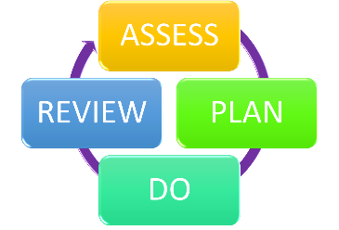
  - Regular Pupil Progress Review Meetings
  - Reviewing the impact of interventions after approximately 10 - 12 weeks
  - Using pupil questionnaires and pupil voice
  - Monitoring by the class teacher and/or SENCO
  - Using class provision maps and assessments to measure progress
  - Holding an annual review (if they have an education, health and care (EHC) plan)

Our in school provision is also externally monitored and reviewed by external stakeholders such as the Local Authority, as well as regularly monitored by our Governing Body.

- How will the school ensure my child has appropriate resources?
All schools receive a Notional SEN Budget, in order to provide for and meet the needs of pupils will SEND.
It may be that your child’s needs mean we need to provide additional resources such as:
  - Additional resources to support their learning
  - Additional more targeted adult time and support
  - Adaptations to in class support
  - Further training for our staff
  - External specialist expertise
Where appropriate, we will consult with external agencies to get recommendations on what will best help your child access their learning and use our best endeavours to ensure these are supplied.

- How will the school make sure my child is included in activities alongside pupils who don’t have SEND?

The expectation is that all schools provide an inclusive provision for all pupils. It may be necessary for some pupils to receive interventions, in addition to the broad and balanced curriculum on offer for all pupils.
We support children and young people with SEN/D to ensure none of our children or young people are treated less favourably than any other child or young person by:
  - Ensuring our inclusive ethos is embraced by all
  - Developing our children and young people’s understanding and appreciation of uniqueness
  - Nurturing all of our children and young people’s developing talents and strengths

All clubs, trips and activities offered to pupils at Littlebourne CE Primary School are available to children and young people with Special Educational Needs and/or Disabilities, either with or without an Education, Health and Care Plan. Where it is necessary, the school will use the resources available to provide additional adult support to enable the safe participation of the child/young person in the activity. We will seek to make reasonable adjustments and we will liaise with parents/carers to consider how we can overcome any potential barriers. Where appropriate, an individual risk assessment will be written. Occasionally parents/carers may be asked to accompany their child/young person to facilitate their inclusion in specific school activities to ensure their safety.

All children and young people with SEN/D are encouraged to be part of the extracurricular clubs (when operational) in order to promote teamwork, building friendships and as part of any additional opportunities available to children/young people with no SEN/D. All of our extracurricular activities and school visits are available to all our children and young people, including our Breakfast Club and extracurricular after school clubs.

All children and young people are encouraged to go on our residential trip(s) when available. We adapt this trip to support our children and young people, which may include adapting the offer of our residential trip. In these circumstances, the SENCO works closely with the family and child/young person to support attendance.

All children and young people are encouraged to take part in sports day/school plays/whole class workshops and experience events.

No pupil is ever excluded from taking part in these activities because of their SEN or disability and we will use the resources available to us, in order to make whatever reasonable adjustments are required to promote their access and inclusion to these valuable opportunities.
Where required, risk assessments may inform school decisions around participation in identified activities or events.
- How does the school make sure the admissions process is fair for pupils with SEN or a disability?
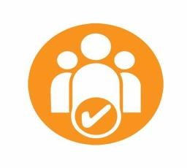
At Littlebourne, our admission arrangements for children without an Education Health and Care Plan do not discriminate against or disadvantage children with SEN and/or disabilities.
We follow KCC processes for admissions, which gives priority for children with EHCPs to be admitted, before other places are allocated, in line with KCC SEND Departments consultation process.

- How does the school support pupils with disabilities?

Under the Equality Act (2010( you are classed as disabled if you have a physical or mental impairment that has a ‘substantial’ and ‘long-term’ negative effect on your ability to access and participate in normal daily activities.
We are continuously reviewing and developing our in school provision to more effectively meet the needs of our whole school, including those with SEN and/or disabilities.
Please see our Accessibility Plan for more information, Accessibility Plan - 2023-2026
- How will the school support my child’s mental health and emotional and social development?

We provide support for pupils to progress in their emotional and social development in the following ways:
  - Pupils with SEND are encouraged to be part of the School Council and other leadership groups such as Wellbeing Warriors
  - Pupils with SEND are also encouraged to be part of clubs to promote teamwork/building friendships
  - We provide extra pastoral support for listening to the views of pupils with SEND  Additional support is available

We have a zero tolerance approach to bullying of any member of our school community (children, young people and adults). This is reflected in our school Anti- bullying policy Littlebourne Antibullying Policy 2024

We prevent bullying through proactive education approaches utilising our PSHE programme Jigsaw to support our children develop as balanced individuals and through maintaining and reinforcing our school vision and values. We use restorative justice approaches to support our children to understand the impact of their actions in order to develop socially, resolve conflict positively and prevent harm within our school community.

- What support is in place for looked-after and previously looked-after children with SEND?


Mrs McLean, our SENCO, is also our designated teacher for looked after children and previously looked after children. This ensures that this provision is seamless and reflects both areas of challenge, ensuring that all teachers understand how a looked-after or previously looked-after pupil’s circumstances and their SEND might interact, and what the implications are for teaching and learning.
Pupils who are looked-after or previously looked-after, will be supported much in the same way as any other child who has SEND. However, looked-after pupils will also have a personal education plan (PEP). We will make sure that the PEP and any SEND support plans or EHC plans are consistent and complement one another.

- What support will be available for my child as they transition between classes or settings or in preparing for adulthood?
Littlebourne implements a robust transition process for all children in our school community and intensify this for children with SEND when required, to ensure all children are prepared for the next part of their education journey.

Between Phases – Nursery/ Pre School to Primary School

At Littlebourne CE Primary School, we work closely with the educational settings attended by new children and young people before they transfer to us, in order to seek the information that will make the transfer as seamless as possible.


Arrangements may include:

  - Teacher (and SENCO where appropriate) visits to Nursery/current setting
  - Transition events/afternoons within school
Where a child or young person has been identified with SEN/D prior to starting school, we work closely with pre-school settings, Specialist Teachers/Health Professionals and parents/carers to gather information and to plan for additional support as needed.
This may include:
  - Additional visits/time with staff members
  - Additional transition meetings
  - Additional supports such as general or individualised social stories/visual supports.
Between years
During within school and between phase transitions all our children participate in an extremely thorough and robust transition process throughout Term 6 of the academic year.
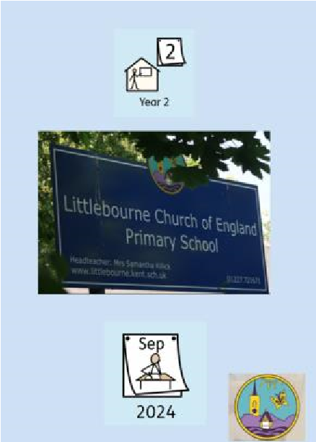
This includes:
  - Transition sessions in their new classroom, which increase in duration
  - Transition sessions with their new staff members
  - Opportunities to work collaboratively within these new environments and achieve success at tasks
  - Visual supports
  - Staff to staff transition documents and meetings

In addition, for our in school transitions , we identify children and young people who may be vulnerable at transition and work collaboratively to put additional supports in place such as:

  - Child/young person friendly additional supports such as general or individualised social stories/visual supports.
  - Additional visits to their new classroom
  - Additional time with new staff members
  - Staff to staff transition documents and meetings

Between schools
When your child is moving on from our school, we will ask you and your child what information you want us to share with the new setting.

Between Phases – Primary School to Secondary School
We also contribute information to a child or young persons’ onward destination by providing information to their next setting.
The SENCO of the secondary school will come into our school for a meeting with our SENCO. They will discuss the needs of all the pupils who are receiving SEND support.
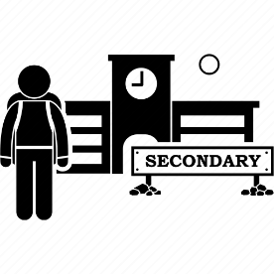
Pupils will be prepared for the transition by:
  - Practising with a secondary school timetable
  - Learning how to get organised independently
  - Plugging any gaps in knowledge
  - Being set homework to develop understanding of how this works
  - Supported transition days for children and young people at local secondary schools
  - Visits from secondary school teachers to meet with transferring children/young people and class teachers.
  - Participation in transition activities with new secondary school staff
  - SENCO attendance at STLS run Primary to Secondary SENCO transition events
  - SENCO attendance at secondary school run Primary to Secondary SENCO transition events
  - If appropriate, additional transition meetings can be arranged to involve parents/carers, children and young people, primary SENCO and secondary SENCO at which further supports may be planned
  - Annual Review Meetings for children and young people with EHC Plans, are also used to plan for and support transitions
  - Canterbury Christian Schools Work Trust support our children with delivery of a Transition workshop afternoon.
  - Children with more complex needs may attend additional transition events during the Summer holidays. This is dependent on secondary school provision.

- What support is available for me and my family?
If you have questions about SEND, or are struggling to cope, please get in touch to let us know. We want to support you, your child and your family.

Kent County Council publishes information about their Local Offer on their website: KCC Local Offer Information
To see what support is available to you locally, have a

look at Kent County Council’s Local Offer through the SEND Information Hub: KCC SEND Information Hub IASK also explain the Local Offer in their parent/carer booklet: IASK Local Offer Booklet

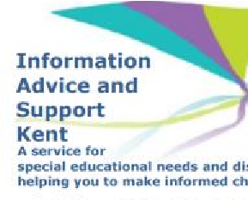
Our local special educational needs and disabilities information advice and support services (SENDIASS) organisations are:
IASK
Local charities that offer information and support to families of pupils with SEND are:
SEND Information Hub
National charities that offer information and support to families of pupils with SEND are:
IPSEA
SEND family support
NSPCC
Family Action
Special Needs Jungle

18. What should I do if I have a complaint about my child’s SEND support?

In line with our complaints policy, where parents/carers have concerns about Littlebourne’s SEN/D provision, we encourage them to first raise their concerns informally with:
- Their child/young person’s class teacher
- The SENCO
- The Headteacher

Littlebourne CE Primary School Complaints Policy and Procedure
They will try to resolve the complaint informally, in the first instance.
If this does not resolve the raised concerns, parents/carers are welcome to submit their complaint formally.
Formal complaints about SEN/D provision in our school should be made to the Headteacher in the first instance. These will be addressed, in line with Stage 1 of the school’s complaints policy.
Littlebourne CE Primary School Complaints Policy and Procedure
If parents/carers are not satisfied with the school’s response, they have the right to escalate the complaint to the Governing Body, as per Stage 2 of Littlebourne’s Complaints Policy.
Littlebourne CE Primary School Complaints Policy and Procedure
In some circumstances, this right also applies to the child/young person themselves.
Parents/carers would seek to follow this route if their complaint is about SEN/D provision in school, which covers the following aspects –
- General In School SEN/D provision
- Specific provision for individual children/young people who do not have an Education, Health and Care Plan
- In school disability discrimination
For all other complaints, it may be more appropriate, to make these to the relevant outside body.
To see a full explanation of suitable avenues for complaints regarding SEN/D provision and who to approach with these, see pages 246 and 247 of the SEND Code of Practice.
If you feel that our school discriminated against your child because of their SEND, you have the right to make a discrimination claim to the first-tier SEND tribunal. To find out how to make such a claim, you should visit: https://www.gov.uk/complain-about-school/disability-discrimination You can make a claim about alleged discrimination regarding:
- Admission
- Exclusion
- Provision of education and associated services
- Making reasonable adjustments, including the provision of auxiliary aids and services

Before going to a SEND tribunal, you can go through processes called disagreement resolution or mediation, where you try to resolve your disagreement before it reaches the tribunal.
To find out about disagreement resolution and mediation services in our local area, see KCC’s offer here KCC's Mediation and Resolution Service
Kent County Council, our Local Authority, have made contractual arrangements with Global Mediation services to ensure fully qualified and experienced mediators are available should they be requested. Global Mediation offers Mediation Advice and Disagreement Resolution services.

In order to request mediation, please contact Global Mediation directly via their website.
https://www.globalmediation.co.uk/service/special-educational-needs-disability/

- Supporting documents

  - Littlebourne Equality and Objectives Information
  - Littlebourne Child Protection Policy
  - Littlebourne Behaviour Policy
  - Littlebourne Accessibility Plan
  - Attendance Policy
  - Littlebourne SEND Policy
  - Littlebourne Parent/Carer SEND Booklet
  - SEN & Disabilities Code Of Practice 2015
  - KCC Mainstream Core Standards

- Glossary
Access arrangements – special arrangements to allow pupils with SEND to access assessments or exams
Annual review – an annual meeting to review the provision in a pupil’s EHC plan
Area of need – the 4 areas of need describe different types of needs a pupil with SEND can have. The 4 areas are communication and interaction; cognition and learning; physical and/or sensory; and social, emotional and mental health needs.
CAMHS – child and adolescent mental health services
Differentiation – when teachers adapt how they teach in response to a pupil’s needs
EHC needs assessment – the needs assessment is the first step on the way to securing an EHC plan. The local authority will do an assessment to decide whether a child needs an EHC plan.
EHC plan – an education, health and care plan is a legally-binding document that sets out a child’s needs and the provision that will be put in place to meet their needs.
First-tier tribunal/SEND tribunal – a court where you can appeal against the local authority’s decisions about EHC needs assessments or plans and against discrimination by a school or local authority due to SEND
Graduated approach – an approach to providing SEND support in which the school provides support in successive cycles of assessing the pupil’s needs, planning the provision, implementing the plan, and reviewing the impact of the action on the pupil
Intervention – a short-term, targeted approach to teaching a pupil with a specific outcome in mind
Local offer – information provided by the local authority which explains what services and support are on offer for pupils with SEND in the local area
Outcome – target for improvement for pupils with SEND. These targets don't necessarily have to be related to academic attainment
Reasonable adjustments – changes that the school must make to remove or reduce any disadvantages caused by a child’s disability
SENCO – the special educational needs co-ordinator
SEN – special educational needs
SEND – special educational needs and disabilities
SEND Code of Practice – the statutory guidance that schools must follow to support pupils with SEND
SEND information report – a report that schools must publish on their website, that explains how the school supports pupils with SEND
SEND support – special educational provision which meets the needs of pupils with SEND
Transition – when a pupil moves between years, phases, schools or institutions or life stages

