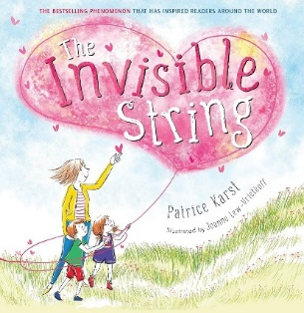
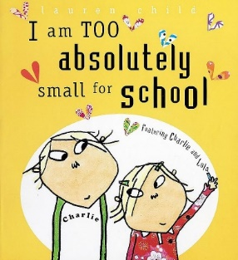


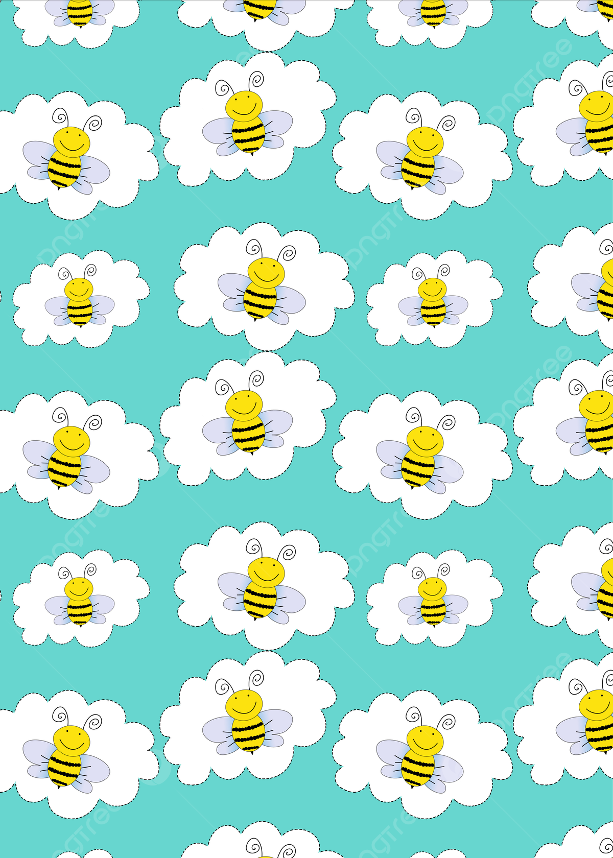
Literacy
We will join in with rhymes and showing an interest in stories with repeated refrains. Identify print and letters in our environment. Begin to understand the key concepts about print: - print has meaning - print can have different purposes - we read English text from left to right and from top to bottom.
R.E
In R.E Bees will be learning about Christianity and exploring the question ‘Why is the word God so important to Christians?’. We will learn this by reading stories from the Bible and finding out about where Christians go to worship.
Phonics
This term Bees will be learning all the following letters and sounds.
s,a,t,p,i,n,m,d,g,o,c,k, ck, e,u,r,h,b,f,l.
We will be learning the new tricky words is, I, and the.
Bees will begin to segment and blend CVC words together.
Art and Design
In the first term Bees will join in with songs; beginning to mix colours, join in with role play games and use resources available for props; build models using construction equipment.
Sing call-and-response songs, so that children can echo phrases of songs you sing.
Self-portraits, junk modelling, take picture of children’s creations and record them explaining what they did.
Understanding the World
Understanding the world involves guiding children to make sense of their physical world and their community. The frequency and range of children’s personal experiences increases their knowledge and sense of the world around them. In term one, we will do this by identifying who’s in their family. Talk about what they do with their family and the places they have been with their family. From this, Bees can identify and discuss similarities and make comparisons between other families.
P.E
In term one, we will be learning movement and development skills during our PE sessions which will be on Wednesdays and Fridays. This will include balancing, taking risks and moving our bodies in different ways.
Term 1 Bees Newsletter
Maths
In maths this term Bees will be learning to compare different objects and sorting objects into groups including finding the odd one out. We will be comparing amounts, size, mass, and capacity.
Bees will identify simple patterns as well as notice mistakes in patterns.
We are going to look at ways of representing 123, comparing 123, then subitise objects in groups of 1,2,3.
Bees will also identify and describe circles and triangles using mathematical language, then make pictures from shapes and sort shapes into groups.

