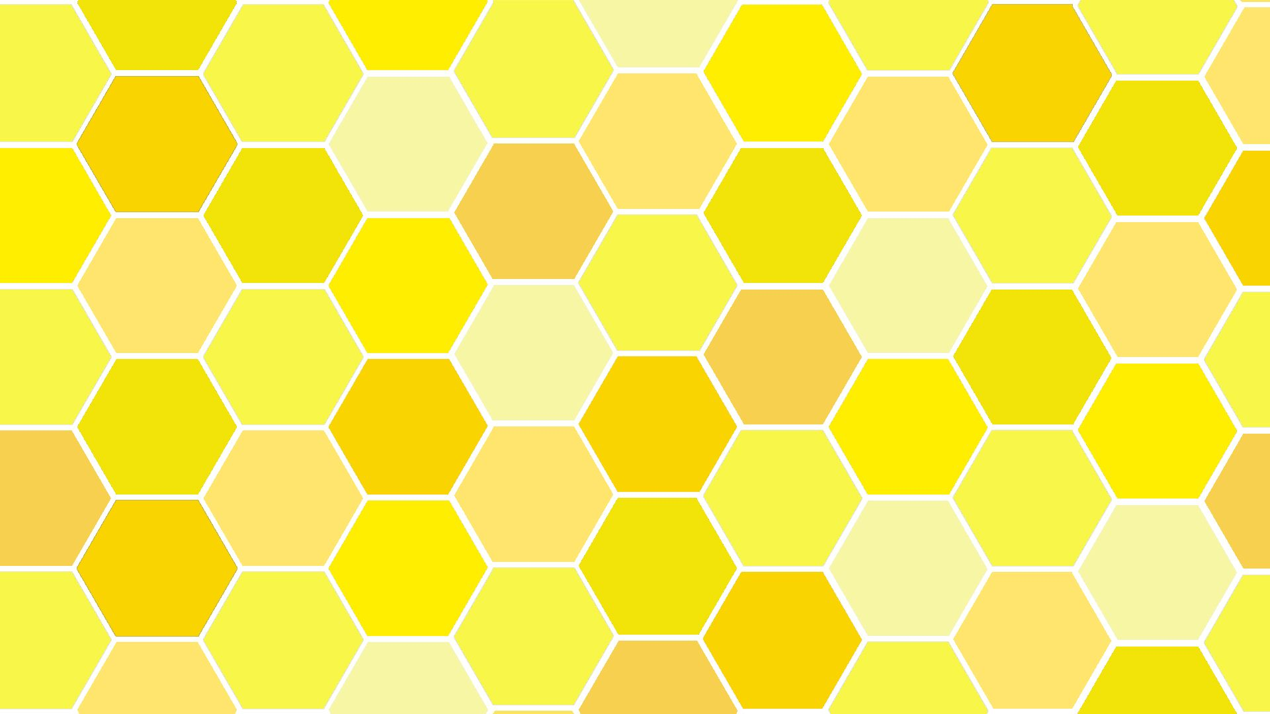
*PE on Tuesdays.
*Book change on Fridays.
Term 2 Bees Newsletter- Celebrations!
Literacy
Bees will be retelling stories related to events through acting/role play.
Sequencing stories and using vocabulary of beginning, middle and end.
Blend sounds into words, so that they can read short words made up of known letter– sound correspondences.
Enjoys an increasing range of books.
Name writing, labelling using initial sounds
Understanding the World
-Bees will talk about what they have done with their families during Christmas’ in the past.
-Show photos of how Christmas used to be celebrated in the past. Use world maps to show children where some stories are based. Use the Jolly Postman to draw information from a map and begin to understand why maps are so important to postmen.
-Share different cultures through celebrations around the world.
Phonics
This term Bees will be learning all the following letter sounds and digraphs (2 letters making 1 sound).
ff, ll, ss, j, v, w, x, y, z, qu, ch, sh, th, ng and nk.
We will be learning the new tricky words put, pull, full, as, and, has, his, her, go, no, to, into, she, he, of and go.


P.E
In term 2, P.E will continue to be on Tuesdays. Our theme this term will be fun and games. This theme covers jumping, catching, throwing and more. Children will learn to negotiate space and obstacles safely, with consideration for themselves and others.

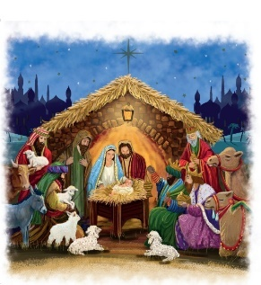
R.E
In R.E Bees will be exploring the question ‘Why do Christians perform nativity plays at Christmas?’. We will discuss parts of the Bible where Jesus is a baby and others when he is an adult. From this, we can better understand the relationship between God and Jesus and talk about why they are so important to Christians.
Art and Design
In term 2, Bees will explore art and design by making Firework pictures. Christmas decorations, Christmas cards and Christmas songs. Bees will also explore role Play Party’s and Celebrations Role Play of The Nativity. We will also create our own Diva lamps and Rangoli patterns, when we learn about different cultures and traditions.
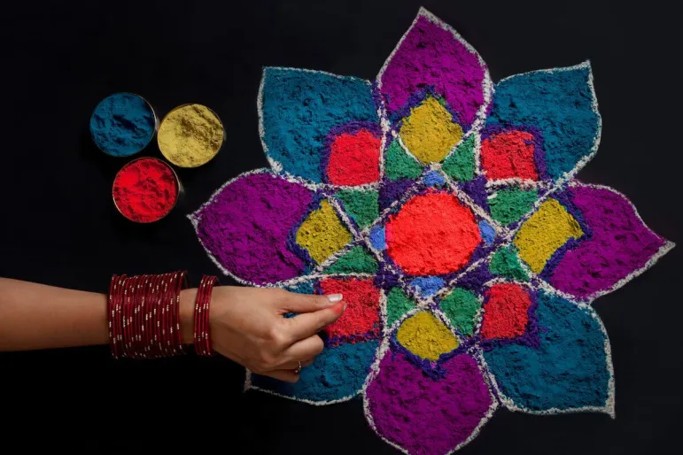

Maths
Bees will be focusing on:
-Counting up to six objects. Using the vocabulary one more or one fewer. As well as ordering numbers 1 – 6.
-Exploring addition and subtraction within 6, and using number sentences.
-Estimate, order compare, discuss and explore capacity, weight and lengths.
-Describe, and sort 2-D & 3-D shapes.
-Days of the week, seasons •Sequence daily events.

